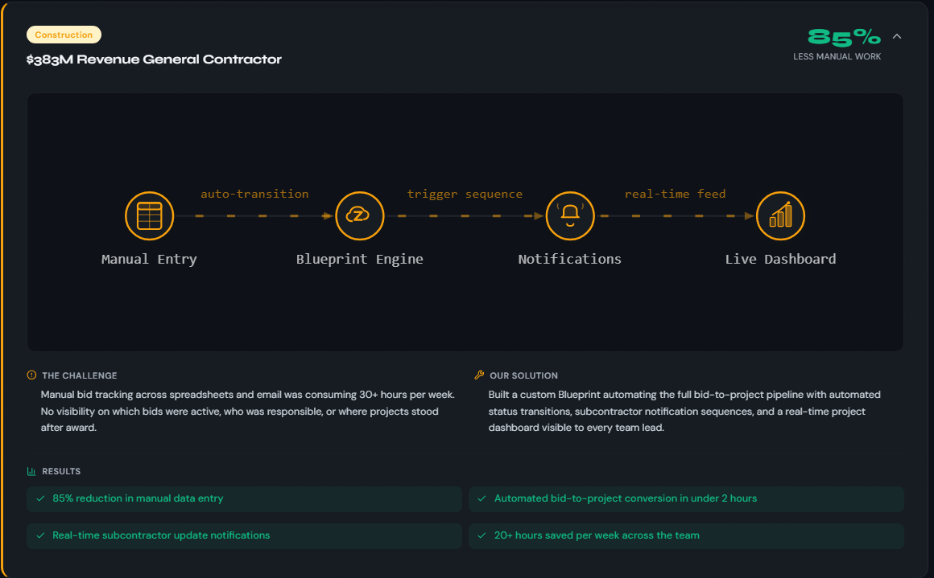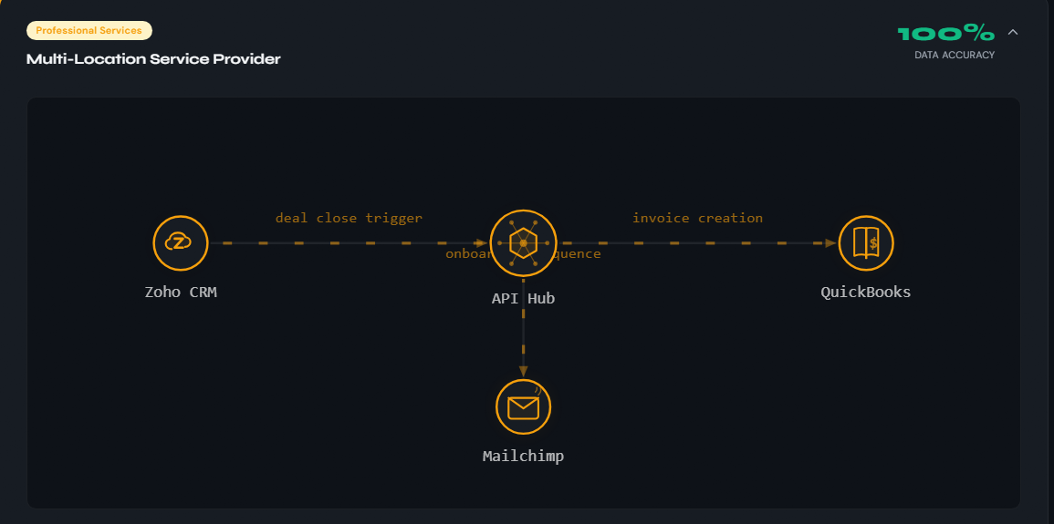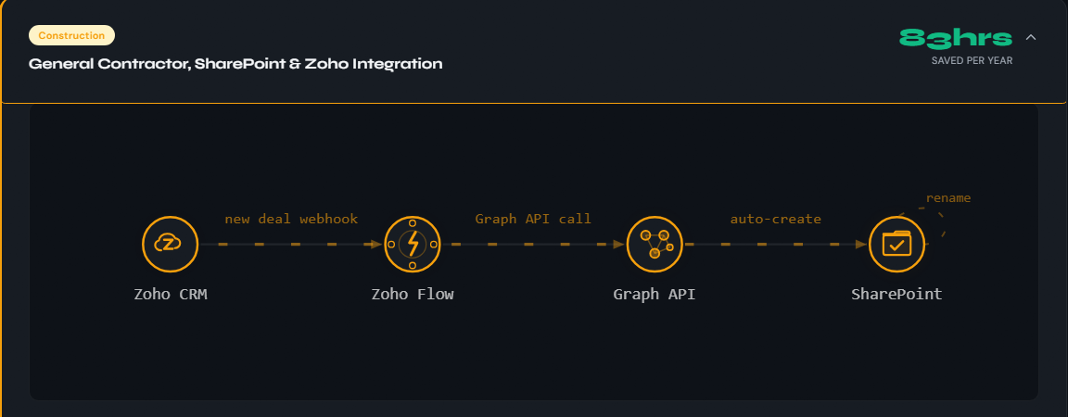

CRM Implementation & Automation
A CRM rebuilt around your sales process. Blueprint automation, custom fields that match how you actually quote and close, and integrations that wire it into the rest of your stack — QuickBooks, Mailchimp, your ERP. Most clients are owner-operated GCs and subcontractors stuck doing pipeline tracking in spreadsheets.

Custom Web Apps
Internal tools built for the work you do once a week and hate every time. Estimating software that turns a job intake into a clean proposal. Quote builders, scheduling tools, lightweight project trackers. Built fast in modern stacks — your team uses it Monday morning, not next quarter.

Website Builds
AI-accelerated, human-finished sites for trades, professional services, and small businesses. First draft in 36-48 hours. The kind of motion-led design large agencies charge $25K+ for — at a budget that makes sense for a small business.

